**Program - 1:**

Write a function for given formula:

answer =

Input: n, z, i, k, theta

Output: answer

Code:-

var n,z,i,k,theta;

var n = 2;

var z = 25;

var i = 2;

var k = 2;

var theta = 8;

var z_1 = Math.pow(Math.abs(z) ,1/n)

var thta = (Math.E)*i * ((theta + (2*k*Math.PI))) ;

var divideByN = thta/n;

// console.log(divideByN);

var thz = z_1 * divideByN;

console.log(thz);

Outpu:-



**Program - 2:**

Create two arrays one containing numbers from 0-9 and the second containing letters from

a-e. Create 10 random pairs of 3 alphanumeric and store them in an array.

Input:

numberArray = [0,1,2,3,4,5,6,7,8,9]

letterArray = [‘a’,’b’,’c’,’d’,’e’]

Output:

[5ab, ba6, 23a, …, ec0]

Code:-

var letterarray = ['a', 'b', 'c', 'd', 'e'];

var number = [0,1,2,3,4,5,6,7,8,9];

for(i= 0; i < 10; i++){

let a = [letterarray[(parseInt(Math.random() * 5))], number[(parseInt(Math.random() * 10))]];

let b = [letterarray[(parseInt(Math.random() * 5))], number[(parseInt(Math.random() * 10))]];

// let b = [letterarray[Math.floor(Math.random() * 5)], number[Math.floor(Math.random() * 10)]];

let c = b[(parseInt(Math.random()* 2))];

// console.log(a, b, c);

a.push(c);

var finalarray = [];

while(a.length > 0){

var index = parseInt(Math.random()* a.length);

var val =a[index]

a.splice(index, 1)

finalarray.push(val)

}

console.log(finalarray);

}

Output:-

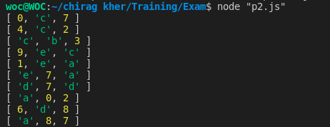

**Program - 3:**

Take two input array and Create final array of 100 random JSON elements.

Each elements contains three value:

Category: Random from given input category array

Age: Random from given input age array

Visitors: Any random number between 0 to 100

Code:-

var category = ["movie","news","education","sports","politics"]

var age = ["teenager","adult"]

var output = [];

for(let i = 0; i < 100; i++){

output.push({agE:age[(parseInt(Math.random()*2))],

cartegorY:category[(parseInt(Math.random()* 5))],

visitorS:(parseInt(Math.random() *100+1))});

}

console.log(output);

Output:-

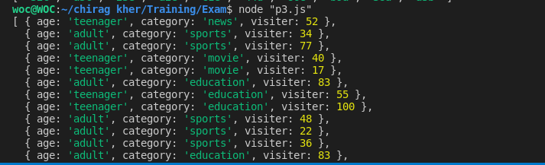

**Program - 4:**

Take output of Program - 3 as input and get following output:

-

-

-

Output contains json which takes a category as key and an array of two percent as

value.

First value is rate of teenage visitor of that category

Second value is rate of adult visitor of that category

Input:

var data

{ age:

{ age:

...

{ age:

]

= [

'teenager', category: 'education', visitors: 91 },

'teenager', category: 'movie', visitors: 83 },

'teenager', category: 'politics', visitors: 65 }

Output:

Ans = {

movie: ["20%", "10%"],

news: ["10%", "20%"],

education: ["5%", "10%"],

sports: ["10%", "5%"],

politics: ["0%", "10%"],

}

var category = [

"movie",

"news",

"education",

"sports",

"politics"

]

var age = [

"teenager",

"adult"

]

farray=[];

var tm=0,am=0,tn=0,an=0,te=0,ae=0,tsx=0,asx=0,tp=0,ap=0,tt=0,ta=0;

for(i=0;i<100;i++){

let a = Math.floor((Math.random() * 100));

let b = category[Math.floor((Math.random() * category.length))];

let c = age[Math.floor((Math.random() * age.length))];

var obj = {age: c, category:b, Visitors:a }

if(obj.age == "teenager" && obj.category == "movie" ){

tm= tm+ obj.Visitors;

}

if(obj.age == "adult" && obj.category == "movie" ){

am= am+ obj.Visitors;

}

if(obj.age == "teenager" && obj.category == "news" ){

tn= tn+ obj.Visitors;

}

if(obj.age == "adult" && obj.category == "news" ){

an= an+ obj.Visitors;

}

if(obj.age == "teenager" && obj.category == "education" ){

te= te+ obj.Visitors;

}

if(obj.age == "adult" && obj.category == "education" ){

ae= ae+ obj.Visitors;

}

if(obj.age == "teenager" && obj.category == "sports" ){

tsx= tsx+ obj.Visitors;

}

// console.log(tsx);

if(obj.age == "adult" && obj.category == "sports" ){

asx= asx+ obj.Visitors;

}

if(obj.age == "teenager" && obj.category == "politics" ){

tp= tp+ obj.Visitors;

}

if(obj.age == "adult" && obj.category == "politics" ){

ap= ap+ obj.Visitors;

}

if(obj.age == "teenager"){

tt= tt + obj.Visitors;

}

if(obj.age == "adult"){

ta= ta + obj.Visitors;

}

}

let totalv = tt + ta;

let totaltp = ((tt*100)/(totalv));

let totalap = ((ta*100)/(totalv));

let totaltmp = ((tm*totaltp)/(tt));

let totalamp = ((am*totalap)/(ta));

// console.log("tp: " + totaltmp);

// console.log(totalamp);

let totaltnp = ((tn*totaltp)/(tt));

let totalanp = ((an*totalap)/(ta));

// console.log("tp: " + totaltnp);

// console.log(totalanp);

let totaltep = ((te*totaltp)/(tt));

let totalaep = ((ae*totalap)/(ta));

// console.log("tp :" + totaltep);

// console.log(totalaep);

let totaltsp = ((tsx*totaltp)/(tt));

let totalasp = ((asx*totalap)/(ta));

// console.log("tp: " + totaltsp);

// console.log(totalasp);

let totaltpp = ((tp*totaltp)/(tt));

let totalapp = ((ap*totalap)/(ta));

// console.log("tp: " + totaltpp);

// console.log(totalapp);

console.log("movie: "+ Math.round(totaltmp)+"%"+" "+Math.round(totalamp)+"%")

console.log("news: "+ Math.round(totaltnp)+"%"+" "+Math.round(totalanp)+"%")

console.log("education: "+ Math.round(totaltep)+"%"+" "+Math.round(totalaep)+"%")

console.log("sport: "+ Math.round(totaltsp)+"%"+" "+Math.round(totalasp)+"%")

console.log("politics: "+ Math.round(totaltpp)+"%"+" "+Math.round(totalapp)+"%")

